**SPARQL QUERIES – Weather Quality Application**

LIST OF PREFIXES:

PREFIX ns: <http://www.semanticweb.org/admin/ontologies/2022/2/untitled-ontology-30#>

PREFIX rdf: <http://www.w3.org/1999/02/22-rdf-syntax-ns#>

PREFIX rdfs: <http://www.w3.org/2000/01/rdf-schema#>

PREFIX owl: <http://www.w3.org/2002/07/owl#>

PREFIX xsd: <http://www.w3.org/2001/XMLSchema#>

**/// Not Imposed SPARQL Queries ///**

1. List the instances of City (list all the cities)

*(si c'est trop lourd mettre un limit ou un filter sur python pour le résultat final)*

SELECT DISTINCT ?name ?lon ?lat

WHERE {

?target ns:city ?city.

?target ns:city ?name.

?target ns:longitude ?lon.

?target ns:latitude ?lat.

}

ORDER BY ?name

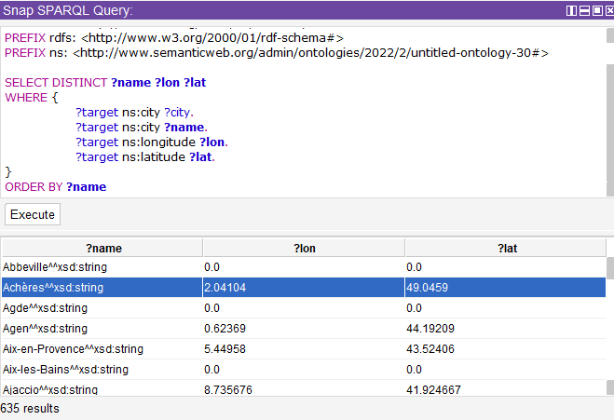

2. List all today's O3 of cities

SELECT DISTINCT **?todayo3** **?name**

WHERE {

?target ns:city ?Airquf.

?target ns:city **?name**.

?target ns:today_o3_average **?todayo3**.

}

ORDER BY **?name**

3. Display the min and max temperature of each cities

SELECT DISTINCT **?min ?max** **?name**

WHERE {

?target ns:city ?Weather.

?target ns:city **?name**.

?target ns:temp_min **?min**.

?target ns:temp_max **?max**.

}

ORDER BY **?name**

4. Display the description (description, humidity, temp) of Paris

SELECT DISTINCT **?des ?hum ?temp**

WHERE {

?target ns:city ?Weather.

?target ns:city "Paris".

?target ns:description **?des**.

?target ns:humidity **?hum**.

?target ns:temp **?temp**.

}

5. Display all the cities where the predicted 03 is higher than the current 03.

SELECT DISTINCT **?name** **?o3a ?o3p**

WHERE {

?target ns:city ?Airquf.

?target ns:city **?name**.

?target ns:today_o3_average **?o3a**.

?target ns:tomorrow_o3_average **?o3p**.

FILTER(**?o3a**<**?o3p**).

}

ORDER BY **?name**

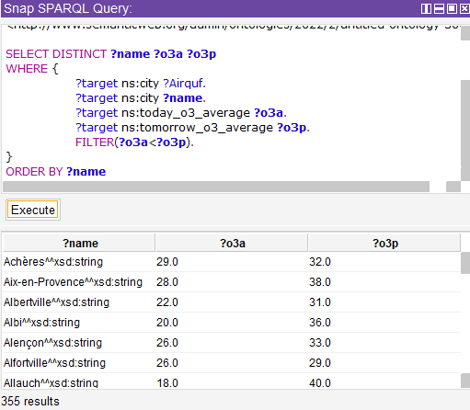

**/// Imposed 5 SPARQL Queries ///**

1. *A query that contains at least 2 optional graph Patterns*

Display the multiple graph pattern of all the cities and their aqi index and o3 index

SELECT distinct **?name** **?aqi ?o3**

WHERE { ?target ns:city ?Airquf .

?target ns:city **?name**

OPTIONAL { ?target ns:aqi **?aqi** } .

OPTIONAL { ?target ns:today_o3_average **?o3**}.

}

ORDER BY **?name**

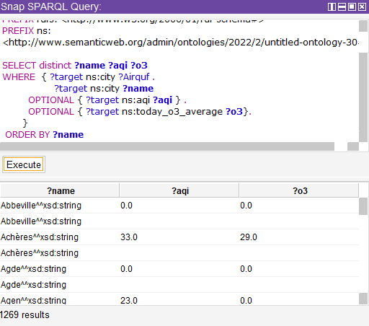

1. *A query that contains at least 2 alternatives and conjunctions*

Display all the cities WHERE the current temperature is higher than 15 AND less than 20 degrees

1. *A query that contains a CONSTRUCT query form*

Display (create axioms) of all cities and their weather description

ASK { ?x foaf:name "Alice" }

CONSTRUCT {

**?city** ns:description **?description**

}

WHERE {

**?city** ns:description **?description** .

}

*d) A query that contains an ASK query form*

?

*e) A query that contains a DESCRIBE query form*

?

Define some SWRL rules